Iteration Plan:
Iteration #2

Group 12

Kyle Nickerson,
Catherine Rendell &
Ben Morrison

Github repository: https://github.com/BigTuna08/cs3716

Plan

Continuing with the feature driven development approach, we will be implementing the remaining 2 features which are necessary for our client to be satisfied. These features are

- Room Request Creation
- Room Request Approval

Once we have implemented these features, the essence of our system will be implemented, with all the basic functionality that our client has told us is necessary.

UC: Applicant requests a room
1. User identifies self as Applicant
2. Applicant determines which space they would like too book.
3. Applicant determines when they would like to book the space for.
4. Applicant checks allocation schedule, too ensure this booking is available.
Repeat steps 2-4 until an available space and time are chosen.
5. Applicant submits booking request.
5a. Applicant rescinds booking request.
1. Applicant issues requests to cancel their booking request.
2. Applicant receives confirmation of cancellation of their request.
6. Applicant is notified their booking request was confirmed or denied.
Repeat steps 2-6 until request is confirmed
Sequence for Requesting Room
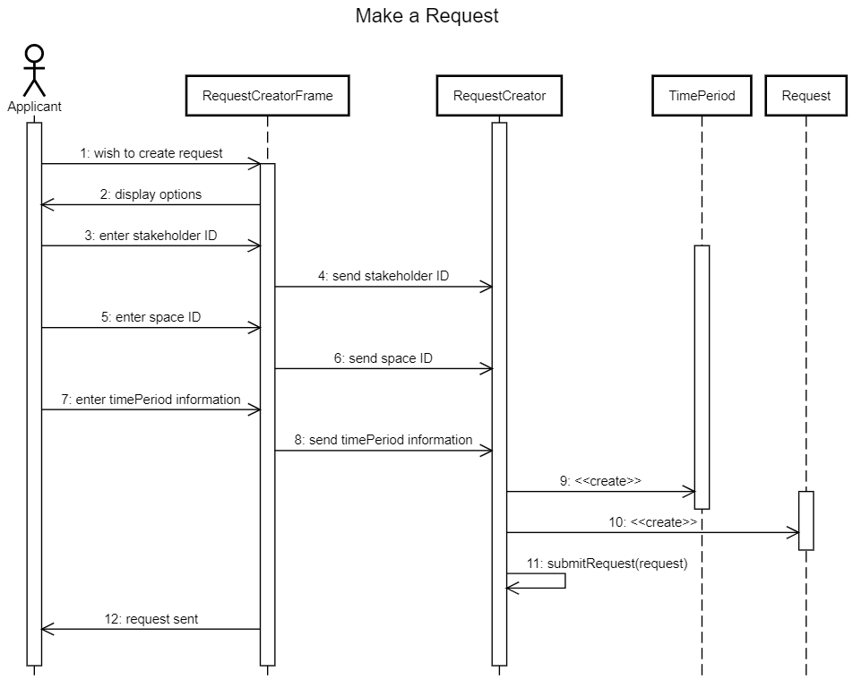

UC: Principal approves request
1. The principal starts the program and indicates that he/she is the principal
2. The system displays the list of possible actions the principal can take
3. The principal chooses to approve request
4. There are or are not available requests
4a. The system displays a list of pending requests
4b. The system informs the principal there are no pending requests
1. Repeat steps 2-10 as needed
5. The principal selects one of the pending requests
6. The system displays the specifics of the request (time slot, group name, etc.)
7. The system prompts the principal to approve or decline the request
8. The principal approves or declines the request
8a. The principal approves the request
1. There is no scheduling conflict
1.1 The system stores the approved request in the schedule
2. There is a scheduling conflict
2.1 The system warns the principal there is a scheduling conflict
2.2 The principal is prompted to decline one of the requests
2.3 The principal chooses a request to decline
2.4 The system updates the schedule
8b. The principal declines the request
9. The system prompts the principal to keep approving requests
10. The principal decides whether to continue reviewing requests
10a. The principal declines to keep reviewing requests
10b. The principal continues reviewing requests
1. Repeat steps 4-10 as needed
11. The system displays the updated schedule

Sequence for Approving request

